The Knowledge Quarter Community Engagement Sub Group

March 2016 Show and Tell Event

Expression of interest: Project Demonstrations
About the Community Engagement Sub Group

The Knowledge Quarter Community Engagement Sub Group ensures that the activity of the Knowledge Quarter responds, and is sensitive to the needs of local communities in its area. In addition, it provides opportunities to those living and working in these communities to participate with the buildings, resources and projects of Knowledge Quarter Partners.

2. Your activity

The Show and Tell Event

In partnership with the Wellcome Trust, the Community Engagement Sub Group will be holding a Show and tell Event through which Knowledge Quarter Partners engaged in activity with communities have the opportunity to present select community engagement projects, meet and mix with other partner-members and share learning and best practice.

The event is planned to take place on Monday 14 March 2016 in the Reading Room at Wellcome Collection, from 17.00 – 19.00 with the following format:

- Short welcoming talks from the Knowledge Quarter and the Wellcome Trust
- Facilitated networking
- 5 - 7 project showcase demonstrations
- Final words and refreshments

Expression of Interest to take part

We hope that you will find this event sociable and productive, and we would love for you to play a part in it.

Using the form below, we invite you to suggest past, current or upcoming community engagement projects produced by your organisation, that will then be one of a select group of demonstrations showcased at this event. A working group will select 5-7 projects for demonstration from the submissions received, which will then be hosted in the Reading Room, Wellcome’s innovative hybrid gallery, library and events space housed in 183 Euston Road (find out more about the Reading Room at http://wellcomecollection.org/readingroom).

The content and shape of your demonstration is completely up to you, but please bear in mind that we are looking to host demonstrations that cover a variety of subject matters, that require minimal technical support (please note that no A/V will be available to you and you will have one hour for set-up) and introduce projects in creative and engaging ways, particularly.
We will also be producing a booklet compiling any current community engagement projects submitted to us by Knowledge Quarter partners, and the contact details of community engagement practitioners within each Knowledge Quarter organisation. This will only contain information given to us through this form and will be made available to all Knowledge Quarter partners following the event itself.

1
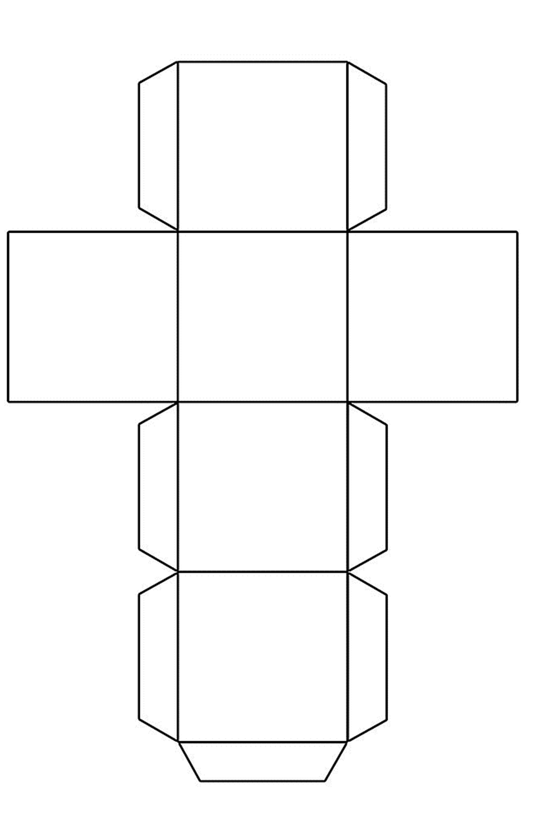
Name of organisation:

……………………………………

Type of organisation:

……………………………………

Contact name and email:

……………………………………

Social media contact details:

……………………………………

Submission of interest form

Which communities do you work with now or would like to work with in the future?
What are your community engagement objectives and how could we help you achieve them?

Tell us a bit about the format of your presentation:
Why would you like to share this project with us?
Title of project demonstration:
2
Contact details for community engagement practitioners

Additional contact details

Using the table below, please provide us with the names, job titles and contact details for a maximum of five community engagement practitioners actively involved in your organisation’s community engagement work that you would like to be invited to this event. Please note that these contact details will be included in the resources produced alongside this meeting which will be shared with all Knowledge Quarter organisations.

First Name | Surname | Job title | Email | Telephone
If you have any questions regarding this event, please do not hesitate to get in touch with Angelo Napolano, Knowledge Quarter Support Officer (angelo.napolano@bl.uk) or Annelise Andersen at the Wellcome Trust (a.andersen@wellcome.ac.uk).
The deadline for form return is Friday 22 January 2016.
Once completed, please send this form to Annelise Andersen at a.andersen@wellcome.ac.uk. The working group will consider all project demonstrations submitted and you will receive an email to thank you for your submission, and to tell you whether your demonstration will appear at this event. Those who presenting will then be invited to see the Reading Room prior to the event itself to see the space and their allotted area.

3

